UNIT OVERVIEW: Education World Language
STAGE ONE: Identify Desired Results
Established Goals/Standards | ACTFL Standards  S1.1, 1.2, 1.3  2.1,  3.1  4.1, 4.2  5.1 | Long-Term Transfer Goals
At the end of the House & Home unit, students will use what they have learned to independently
- Communicate in the target language, in various situations, about their home and the homes of others
- Be aware and understanding of other cultures’ home lives and experiences

 |  | Meaning
 |  | Enduring Understandings  Students will understand that  - Homes can take on many forms  - A person’s culture is often reflected in their home life and design  - Language follows patterns that are often messy and unpredictable  - Studying another culture offers insight into our own  - Language learning involves acquiring strategies to fill communication gaps  - Members of one culture may make assumptions about other cultures based on their own attitudes, values, and beliefs. | Essential Questions  Students will consider such questions as…  How can I use new vocabulary to communicate in the target language?  How does the content of the World Languages classroom help me understand who I am in the world in which I live?  How can I survive and thrive using the target language in and outside of the classroom?  How will recognizing grammar patterns help me with language acquisition?  How do the practices and perspectives of other cultures compare to my own?  What does a person’s home reflect about their beliefs, practices and other aspects of culture?  How do climate and geography affect architecture?
 |  | Acquisition
 |  | What knowledge will students learn as part of this unit?  - Vocabulary and phrases useful for communicating about houses and homes.  - Rooms in the house, furniture, colors, shapes, size  - Kinds of housing  - Interior/exterior of a home  - Chores  - Syntax strategies such as:  - Commands  - Have vs. Have to  - Present progressive  - About various types of homes and cultural practices and variances within homes from the target culture and in the target language. | What skills will students learn as part of this unit?  - Students will apply house/home vocabulary in order to provide and obtain information and opinions.  - Students will use knowledge of syntax to communicate both expressively and receptively.  - Students will gain an awareness of other cultures’ houses and homes.  - Students will compile all of these skills and knowledge into a design of a dream home in the target language.

STAGE TWO: Determine Acceptable Evidence
 | Assessment Evidence
Criteria to assess understanding:  Teacher created rubrics based on NYS Assessments. | Performance Task focused on Transfer:  - In this performance task, students will create and present a:  Dream House Project (to be completed in TL)  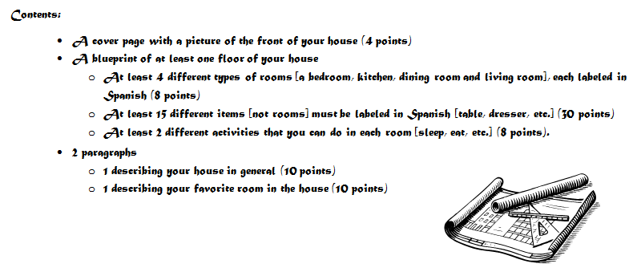  This performance task centers on ACTFL Standards  1.3 Students present information, concepts, and ideas to an audience of listeners or readers on a variety of topics  3.1: Students reinforce and further their knowledge of other disciplines through the foreign language  Teacher Created Rubric  NYS Writing Rubric
Other Assessment Evidence:
Homework, Class Participation, Classwork (listening, reading and writing activities in TL), Informal Speaking Tasks, Quizzes, Unit Test

T, M, A  (Code for Transfer, Meaning Making and Acquisition) | STAGE THREE: Plan Learning Experiences
Lessons 1-3:  A, M  Lessons 4-6:  A, M  Lessons 7-9  M,T  Lesson 10:  A, M, T | Learning Events:  Lessons 1 through 3: Scholars identify and use education vocabulary with imagery, audio and kinesthetic activities in context.  HOUSE BASEMENT RED BLACK SHELF  TOWN-HOUSE A-T-T-I-C ORANGE BROWN LAMP  APARTMENT (#APT) FLOOR YELLOW FURNITURE REFRIGERATOR  LIVING-ROOM HOW-MANY GREEN TABLE S-T-O-V-E  BEDROOM SMALL PURPLE PHONE O-V-E-N  DINING-ROOM MEDIUM BLUE R-U-G S-I-N-K  KITCHEN LARGE PINK CHAIR TRASH/GARBAGE  BATHROOM COLOR WHITE T-V MICROWAVE  CUPBOARDS BED COMPUTER DRESSER CLOSET  BATH-TUB TOILET SHOWER WINDOW DOOR  MAKE THE BED SET THE TABLE VACUUM WASH THE DISHES/CAR/CLOTHES TAKE OUT THE TRASH  DUST SWEEP THE FLOOR CLEAN THE ROOM FEED THE DOG/CAT MOW THE LAWN  Lessons 4 through 6: Scholars are using vocabulary in context and learning how to incorporate informal commands, the present progressive tense and the verb “to have”. Scholars are learning grammatical strategies to express opinions about school and give simple, informal commands. Scholars are practicing expressive and receptive activities.  Lessons 7-9: Scholars create and present a blueprint of their dream house in the TL.  Lesson 10: Scholars will review house/home material and then take unit exam. | Evidence of learning: (formative assessment)  Daily Informal Assessment (Ticket Out the Door, Journals, Warm Up, Class Participation, Graphic Organizers) Lessons 1-9  Quizzes  Presentation of Project (Lesson 9)  Unit Test (Lesson 10)

